Ashwin Aishvarya Vardhan Abhishek Negi Manish Kumar Ujala Singh Amit Kumar  
IIT2015104 IIT2015126 IIT2015133 ISM2015005 IWM2015005 IIITAllahabad IIIT Allahabad IIIT Allahabad IIIT Allahabad IIIT Allahabad

SOFTWARE SOLUTION FOR VISITOR MANAGEMENT SYSTEM

*Abstract*—Our main goal with this project is to develop a smart campus, so as to not lag behind in this era of high-tech advancements. To achieve our goal, we shall make use of the currently popular QR Codes, QR Scanners, GUI forms for registration, web-based front-end for dashboard, and phpmyadmin and firebase for back-end. A basic outlook can be provided as follows: Whenever a visitor enters the campus, they shall be giving their details at the gate, and will be provided a link for the Application on their smartphone. They can then visit the campus, wherein they can be tracked from our central system. Our dashboard will provide general data statistics as well as high-end visualizations, from where we can also control their access data statistics and visualize it. This technology can also be extended towards girls’ safety inside as well as outside the campus. For example, whenever any girl leaves the campus, her “check-out” record will be stored in the database, and will only be removed once she “checks-in” back inside the campus. If she does not, then alerts will be sent to the parents of the girl, the hostel warden, and the chief proctor himself.

INTRODUCTION

For years, visitors, both professional as well as family members of students, have been visiting our institute. However, there is no digital record of them, as no resources have been allocated for digitization of this system. Hence, we are developing a visitor tracking system, which will maintain a digital record of the incoming as well as outgoing visitors, track their movements, and visualize the data obtained in our dashboard. And on the basis of the following observations and visualizations we will be managing our resources. The tracking and data retrieval will be done using QR technology.

# **Motivation**

The motivation for doing this project was the curiosity of creating something new. A product which can be implemented in real time. So we came across the idea of improving the security system of our college. As there are many visitors who keep visiting our campus and it’s really hard to track them as the guards can’t be deployed at every place due to the lack of resources. Also it becomes very typical during the college festivals as there are lot of people who needs to be checked. As there is no system currently installed in our campus which can track the visitors. So idea was quite innovative and we thought of changing idea into reality.

PROBLEM STATEMENT

Every year thousands of visitors visit the college campus. All of them having different purposes of their visit. Some of them are parents or relatives of students or on the other hand they may be the students from other colleges. It’s always hard to keep the track of all the visitors and also maintaining the record. Sometimes we may need the information of the visitors in order to do some analysis. Also the visitors are not supposed to be wandering anywhere all across the campus. As there are some restricted areas where an authorized person is allowed to go. So it’s essential to keep the track of the visitors in order to prevent mishappenings.

So we have to design a proper system which can give the solution of the above problems. A system that can track all the visitors throughout the campus. Give the data about the visitors and the purpose of their visit. And analyzing the obtained or collected data  by which we can optimize our resources. The system will improve the security and surveillance.

**LITRATURE REVIEW**

This[[1]](https://pdfs.semanticscholar.org/1c8e/97e9b8dce97b164be9379461fed9eb23cf3b.pdf) (Al-barhamtoshy, Altalhi & Mashat, 2014) paper automates the students’ attendance system, with the primary target of reducing the time and effort gone into taking attendance offline. The technologies used were Radio Frequency Identification (RFID) and wireless technology which were applied within the campus building (indoor). University Based Services (UBS) and RFID ID tags were used in the paper.  
Keywords: Attendance, Classrooms, RFID Technology, Tags and Readers.

The main research goal of the paper was to provide RFID and Near Field Communication (NFC) technologies for measuring the students’ attendance, participations and monitoring in academic teaching inside the classroom. The modeling requirements were to build a system to access the student database, and to complete the attendance within a few seconds. The RFID tag was included in the student ID card. The attendance procedure could be initiated either automatically, or by the instructor manually, at any time of the lecture. At the completion of the attendance, the reader produces a sound to indicate the same, and the data saved was sent to the central database using wireless network (WLAN). The software was integrated in the client as well as the server device. RFID SDK was used, and the data was fetched using “getter” methods.

This[[2]](http://www.ijesi.org/papers/Vol(3)10/I031080083.pdf) (Sharma, Chatterji & Shimi, 2014) paper talks about how RFID has become a new generation of automatic identification and data collection technology which has helped to automate business processes and has allowed identification of a large number of tagged objects using radio waves. Their employee management system would allow a hands-free control, monitoring the whereabouts of the employee as well as their attendance. The access tag had a range of about 5m (max) from the RFID reader, which in turn was helpful for those who were handicapped, elderly people, staff carrying packages etc. The system was based on UHF RFID readers, supported with antennas at gates and transaction sections, with employee ID cards having RFID transponders which were able to electronically store information that could be read/written even without actual physical contact.   
Keywords: API , GUI, RFID , Readers, Tags/Transponders, UHF.

The system consisted of UHF RFID reader, class 1 gen2 UHF tags, application software and text/binary input and output files. The data was stored in a central database. The readers were installed at the entry/exit gates and were connected to the server using LAN. The reader kept emitting radio signals at regular intervals and generated a signal radius of around 5m. The RFID chip was inserted in the ID card of the employee, so that whenever the employee would pass through the reader, the respective signal would be emitted from the tag. The reader would capture the radio signals, decode it into a byte stream, and send the information for further processing to the server. The information of the reader regarding the port number, IP address, gate number et al. were stored in an editable Access Point file. The software architecture included a communication module, API, user visualization software, and a database.  
  
Another[[3]](http://www.researchpublish.com/download.php?file=Indoor Location Tracking System Using RFID Technology-1082.pdf&act=book) (Karthika, Harriet rathna priya & rathinavel pandian, 2015) paper talks about overcoming the challenge of detecting people in big institutions. Some of the previously used technologies include infrared and WLAN, among others. RFID technology was used there to improve the accuracy and infrastructure for such setups. RFID technology is a power efficient and reasonable technology for tracking, which is fast as well.

Keywords: RFID Tag, RFID reader and Zigbee.

The system was based on the wireless communication services between the reader unit and the tracking unit via Zigbee, and identified the RFID tags to track the location of staff and students. The RFID emitted a low power radio wave field which was used to power up the tag so as to pass on any information contained on the chip. RFID is a member of the family of Automatic Identification and Data Capture (AIDC), and is fast and reliable. Here, there was no need of physical contact as identification was done using electromagnetic waves. The system worked as follows - whenever a student would come within the reader range, the reader would identify the tag, and match it with its own database. If the data were found, “FOUND” was displayed. Otherwise, “NOT FOUND” was displayed. The high-frequency electromagnetic energy and the corresponding  signal generated by the reader triggered the tags. Low pass filters were used. For the system setup, RFID readers were placed in front of each classroom. They consisted of PIC microcontroller, power supply unit, MAX232, RFID reader and tag and zigbee. They can also be connected to various systems using RS-232. The implemented system was highly power efficient and secure.

This paper[[4]](http://interscience.in/IMR_Vol2Iss3/paper9.pdf) presents the study based on theautomated visitor tracking management system. Their visitor management system was useful at those places where a large number of visitors come and visit like colleges, tourist places etc. Their Visitor management solutions provide an ID to visitors in soft copy format. All of the records of that visitors were stored in the database at the time of check-in.Their modern visitor management system was used for restricting the visitors from prohibited area by sounding an alarm or through some notification or through S.M.S. at the time of their visit.

The first technique used was VMS, which stands for visitor management system. Their visitor management system was usually used in keep track of visitors which are coming in and going out. The second technique used was .Net framework. Programs which are written for the .Net framework, those are executed in a software environment ,which is also known as the Common Language Runtime(CLR),an application virtual machine that provides important services such as security, memory management, and exception handling. The third technique used was SQL, referred to as structured Query Language is a programming language which is used for managing and handling data in relational database management  system(RDBMS). The fourth technique used was SQL server, Microsoft SQL server is a relational database server, which was developed by Microsoft. It is a software product which is mainly used for storing and retrieving the data as requested by the software application. This Visitor Management System was used by mainly four users. They are Administrator, Employee, Security and Visitor. Hardware Requirements were Windows 98,ME or 2000 or XP operating systems, Database - Oracle or MS SQL server, Intel Premium Processor 266 MHz or Higher,64 MB RAM ,25 MB of HDD for software installation,USB Webcam (Make - Intel, Logitech, D-link, Creative),Printer(if required). Software Requirements were Net Framework 3.5 for front-end, Microsoft SQL Server 2008 Express Edition for back-end, Certified distribution of windows XP, Vista or 7 as operating system.

Another paper[[5]](https://scholar.colorado.edu/cgi/viewcontent.cgi?article=1031&context=csci_gradetds) throws light on some concepts related to location-aware RFID mobile device system for museum applications. The present capabilities of smartphone devices provide users with novel ways to interact with the world around them and retrieve information about it.This thesis was used to explore how these capabilities may be extended in order to enhance the experience of museum visitors and simultaneously provide museums with valuable data about their visitors.

The extensive capabilities of smartphones can be utilized in revolutionary ways especially by pushing the boundaries of how they are typically used. The technology proposed in this paper  was basic flow of information for typical use was included 3 major components in the system. First component was Radio Frequency Identification (RFID) tags, second component was a mobile device with attached RFID reader apparatus and the last one was a local server that stores all information like images,texts,video or audio. In general description, the idea was RFID tags were placed on or near exhibits in the museum and also on pathways. When a mobile device was within the range of an RFID tag , the tag was transmitting it’s identification number to the reader , which was relay this information to the mobile device. The mobile device was then suppose to transmit this identification number to the server via Wi-Fi or some mobile data. The server was suppose to respond accordingly by transmitting media and location  information related to that particular place which was showing to the user at that time. The server was also suppose to store the timings and tracking information of the currently detected user for evaluation purpose so that museums were able to understand how many users or visitors were moving through museum and spending their time. The basic premise for RFID involves 2 major components in this paper, in which first one was the transponder was the component that was placed on the object or location that were identified and second was the reader transmitted and received RF signals in order to read and/or write to RFID tags.

following reading ranges were used,

|  |  |  |
| --- | --- | --- |
| **Frequency** | **Tag type** | **Theoretical range** |
| LF:125-148 KHz | Passive | <1’ |
| HF:13.56 MHz | Passive | <3’ |
| UHF:680-900 MHz | Passive | <20’ |
| UHF:680-900 MHz | Active | >300’ |

The prototype was developed as below, for the system to function as described previously, three components were interfaced, first was an RFID reader, second was a smart phone and the last one was a server.

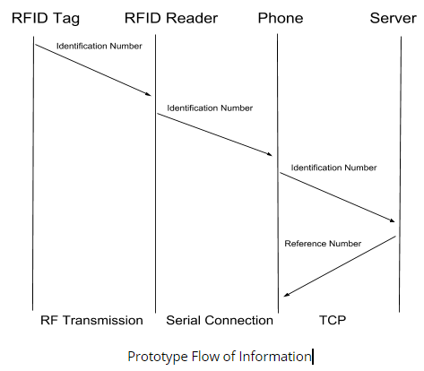

Prototype Flow of Information

Another paper[[6]](http://publicsurveillance.com/papers/Fisher_Monahan_RFID_IJMI.pdf) (A fisher & Monahan, 2008) comprises the concepts related to tracking the social dimensions of RFID systems in hospitals. Radio frequency identification(RFID) is an emerging technology which is rapidly becoming the standard and very useful for hospitals to track inventory, identify patients and manage personnel. Hospital staff specially nurses, express the concern about the surveillance potential of these tracking technologies. Also, nursing staff frequently experienced an impassibility of labor as a result of the implementation of RFID systems because the task of keeping the systems operational often falls upon them.RFID systems allowed for the electronic tagging of assets, inventory, personnel and patients. In this paper, the RFID systems worked by placing the unique electronic identifiers on items in the forms of some stickers or some cards embedded with RFID chips and also they applied on people in the form of bracelets or badges embedded with RFID chips. Once tagged people or items were identified, tracked and managed by using a centralized database. In this paper, they mainly used two types of RFIDs, in which first one was passive and second was active. Active RFIDs contained a miniature battery and actively emitted radio frequencies to the system, and passive RFIDs contained no batteries but instead draw the necessary power to emit a frequency through secondary reader devices such as hand-held wands, which were called “interrogators” by vendors. Before the installation of RFID chips in the hospitals, at that time there was an informal interview conducted with 12 hospital administrators, 8 physician's , 8 nurses,  17 technical hospital staff members, and 15 technology industry vendors and consultants across the country. After that interview, data were collected on experiences of individuals at hospitals that were already using RFIDs successfully. At that informal interview, some of these prompts included,(1) Tell me about your involvement in the implementation of RFID systems in the hospitals.(2) How was the system currently used to track individuals and evaluate workflow?(3) What kind of policies are in place regarding the RFID system?

The move to rationalize and computerize the functions of institutions like healthcare and fitness had seen in the context of post-industrialization. As social creations, technological systems and devices required considerable organizational and industrial investments in order for them to become part of standard practice. Beyond the financial costs that were associated with RFID systems in hospitals, staff must be trained on their use; formal and informal policies crafted to direct daily activities, division of labor spelled out and responsibilities assigned, work overload or labor identified or corrected. There were following recommendation made for implementing or evaluating RFID systems within the complex organizations of hospitals, (1) the need for customized systems when most of the industry systems available are standardized “one size fits all”, (2) the need to establish clear policies and organizational relations when RFID systems and their maintenance was outsourced to external technology companies.

This paper[7] was based on Automatic Vehicle Location (AVL) which  was an advanced method used to track and monitor any remote vehicles which has a software unit that will receive signal and transfer signals through GPS satellite and RFID. AVL is a combination of  Global Positioning System (GPS) and Geographic Information System (GIS) that will provide real time position of each vehicle. In this it was shown that real time vehicular tracking system includes a hardware device and a server at appropriate distance to track the vehicle. The information was transmitted to tracking server using RF transmitter within an appropriate distance.

To achieve Real time tracking of vehicle an active systems were developed that can transmit data in real time via cellular or satellite networks to the computer server. The locations where GPS signals are poor or dead reckoning we use active RFID systems. RFID is a technology that uses communication through the use of radio waves to transfer data between a reader and an electronic tag attached to an object for the purpose of identification and tracking . Its main use is to give unique identification number for each RFID tag or products. For example :- giving unique identification number to each product in the grocery store. RFID tags can be read from few meters from several meters away from the line of sight of the reader. It involves  the hardware known as interrogators( also known as readers) and tags , as well as RFID software. It has two parts - the transponder , which is located on the object to be identified, and the detector which depending upon the design and the technology used, may be a read or write / write device.

This paper[8] deals about how the RFID technology can be used to counter major problems like strengthening the safety aspects of students across the colleges of the world .There is a great management and safety problem as they students sneak out in a mischievous activities uncaught. To solve this a radio transceiver transmits a common radio wave  which is placed in the student ID cards . It transmits a common radio waves which is received by the RFID tags . This wave is then modulated to RFID coils and resent to the receiver.

RFID is also helping in keeping record of students digitally and also approximate position of the student’s position inside the campus. Student’s position data is continuously fed in the server which can be used in many different ways. There is a dispersed system of modems spread throughout the campus for internet facility which help in identifying the location of a person as each transceiver can be integrated to associate with the specific location in the given area.  RFID tags contain electronically stored information about person’s location time and checkpoint .Some tags are used in short ranges via help of electromagnetic induction , others use a local power source such as a battery .RFID is a part of Automatic Identification and Data Capture (AIDC) technologies that includes 1D and 2D barcodes.

This paper[9] discusses how the RFID technology could be used alongside the face recognition system to restrict the entry of unauthorized persons into the hostel. As sometimes it’s not necessary that the person who is carrying the RFID tag will be the same person to whom it was assigned. In such cases we may need the collaboration of some other system along with an RFID system. This research was carried out to deliver a more secure access control system. The system consisted of an RFID system and a face recognition system. Both the systems were installed at the entrance of the hostel. The computer system initially checked whether a user had a valid RFID tag. In further step it captured the image of the person and scanned for the match in its database. If the assigned unique id matched with the person to whom it was assigned then the person was granted access into the hostel. Otherwise he was considered a defaulter and by using the GSM modem emergency call was made to the security van and also the alarms were sounded.

The system comprised of IP10 Proximity RFID card Reader along with the IPC 80 RFID tags which are passive in nature and operates at a frequency of 125KHz, Camera, GSM Modem, AT89C microcontroller, non volatile RAM, Door locks and Alarms.

This paper[10] consisted  of the study that how RFID Technology makes life easier and secure by using this technology with IoT Devices. The internet of things(IoT) is a web of objects which can be accessed via the internet . in this paper[10] they used the embedded Technology to interact with the internal  or the external environment. IoT gives the objects power to identify themselves and perceive the surrounding and interact with servers. RFID is considered as the prerequisite for the IoT. As RFID can be used to sense the objects and also capable of transferring information about the object on a wireless network. The IoT based on RFID consisted of mainly  three major components which included RFID system, Internet System and Middleware system. The RFID System was used as a medium to detect the physical world and it collected the information from physical world which is then sent to middleware. The middleware system is responsible for transmission of information and preprocessing of information. It includes Key Server and ONS(Object Naming Service) Server. Then the final Layer was Internet System which was responsible for analysis, processing, decision making on information  to implement customized services to the user. And established the connection between the things (objects). This also contained the internet and database formerly known as PML database. The IoT which used intelligent barcodes (RFID) which can interact through a networked system to track all the items that are put in the shopping cart. The arrangement can be implemented in the Malls. The RFID tags interact with the reader and thus the every item put in the basket can be detected. The reader was connected with a large network which sends information on purchased products to the retailer or the manufacturers of the product. In order to ensure the system to work correctly each product was given a unique product number. Every Smart label could contain  96 bits of information which includes product manufacturer , product name and the number associated with the product which was of 40 bit. With the help of this system a smart label could communicate with a network called as ONS. Then all the information related to the product will be retrieved on the screen so that user may be able to see the information about the product that he purchased and also to generate the bill.

This paper[[11]](https://www.sciencedirect.com/science/article/pii/S1877705814004949) uses RFID to count the number of persons in a single channel and to monitor them based on the RSSI (Received Signal Strength Indicator ) values of the RFID tags. The RSSI values of the passive tags are analyzed and found to be inversely proportional to the the tag and the corresponding antenna even when the tag is moved parallel to the antenna. The system also finds out the various parameters of pedestrian movement like the number of persons at a particular place , identify the specific person , the location and time of the person in front of corresponding antenna based on the RSSI value which in this case will be maximum. Unlike other methods as by using Image Processing , RSSI method is more efficient and faster and  even in the condition of darkness, fog and smoke in case of fire camera would be inapplicable, this technology is still applicable.

They used a setup of two RFID readers and eight RFID antennas  to obtain the number of persons and specific person in a particular sensing area of an antenna. The channel is considered to be single that is only one person at a time can cross through the channel and person is always going through those antennas as they are fixed. The detection range of the antennas are identified and positions are marked for the first time the tag was detected also at the boundary of place same tag is detected for last time. All the tags are tested against  all antennas to determine and label the largest range of that particular antenna.

Keywords: RFID, RSSI, tag testing, person counting, person monitoring

Based on this observation the next antenna is placed a little distance from the sensing region of  another antenna , and this will ensure that only one antenna would detect a tag at a certain time, so no two antennas can detect the same tag. The antenna also increments the count of the number of persons in its sensing region id the tag is not identified as long as the tag is detected by the antenna within its sensing range. Each tag has its unique ID to distinguish the person from each other. Which means the number of different EPC within the sensing range of a particular antenna is equal to the number of persons in that range. Also from the value of EPC we could identify  the specific person in the sensing range of each antenna.

The paper[[12]](http://ieeexplore.ieee.org/stamp/stamp.jsp?tp=&arnumber=4594880) demonstrates  a location based RFID system using geographic location code longitude and latitude for real time monitoring of RFID tags. For localizing in WSNs and RFID networks they have developed  a new location scheme consisting of landmark which could be a building or specific place. For this coarse-grained location that is a node with its own physical location and its communicating  region managed by it.

The tracking system is implemented by using various components .The system consists of RFID node, relay node, access node, location server, RFID server, middleware and also one wireless sensor node Zigbee composed of a CC2420 IEEE 802.15.4 MAC chip, one ATMEGA128 microcontroller and other components. A 2.4GHz Zigbee node 915MHz UHF multi-protocol RFID reader. A reference node is also used which broadcasts its course-grained location. Firstly  a RFID node gets its location from nearby reference node. The RFID node reads all the tags near it and sends the data associated with those nodes relay node which further sends it to access node which is directly connected to the server and management client. From access node a user requests for tag information to the middleware which simultaneously ask to RFID server about tag’s location information. The server sends back data to the user’s application program on access node. The application program displays the tag’s information and location on the map. Client’s application program  can also show the mobility history of the RFID tag.

**INFEASIBILITY STUDY OF RFID**

There are various challenges and issues which can be faced while working with RFIDs. RFID is not the best for all type of tracking as there can be some problems while working with RFIDs.

Some of the major issues with RFID are as follow :

**1.Cost:**

There are different kind of RFIDs available in the market.  They have different operating frequencies and also a wide range of prices. According to our requirement we were supposed to be using UHF and HF RFIDs which are expensive. The HF RFID reader costs around Rs 20000+. And UHF RFIDs are even more expensive. It’s not feasible to purchase the required amount of RFIDs within the stipulated time.

**2. Trouble in operation:**

There are some certain things which may cause the problem in correct working of RFID. The metal and the liquids can cause such problems as the metals whenever they come across the radio frequencies they scatter the radio frequencies which in result lead to false readings.

Same is the problem with liquids as the liquids absorb the received frequencies. RFID readers get reading when they receive the reflected or transmitted signals from the tags. Due to the presence of liquids radio frequencies are absorbed and are not detected by the readers.

**3. Reader Collision Problem**:

In an environment where you are using the multiple RFID readers then the performance of these readers is limited by the reader collision problem. If there are limited channels then the in-channel collision may increase when the antennas are facing to each other. If a tag is in between the two antennas then it may lead to the inconsistency as thi tag will be detected at multiple places at the same time which leads to the discrepancy in database.

**AN ALTERNATIVE TO RFID : QR CODE**

Quick Response also known as QR which is a reference to the high speed by which the data can be decoded with scanners. It is a kind of 2 Dimensional Code which was originally developed in Japan by Denso Wave. QR code is also sometimes referred as 2D Barcode. It is a machine readable code consisting of white and black modules. It has the capability of holding thousands of alphanumeric characters. The information stored inside the code can be text, an Address or something else. The basic need of developing the QR code was the limitation  of barcodes having the capacity to store only upto 20 alphanumeric characters.

.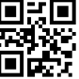

QR Code (source: google images)

The QR codes are being used in wide areas these days mostly in entertainment, product labeling and in the smartphone applications. Users can open the URL Associated with the QR code through their smartphones.

QR code system is formed with an encoder and a decoder. Encoder encodes the data and generates the QR code while on the other hand Decoder is responsible for extracting information from the QR Code.[13]

**ADVANTAGES OF USING QR CODE OVER RFID**

1. **QR code Deployment :**

Unlike the RFIDs which needs to be deployed at the specific place there is no such issue with QR code. As QR code can be printed anywhere on any kind of objects. So it’s easier to make it available at most of the places. The QR code is a square code and is quite visible on any kind of surface. Due ti this fact the people are not required to be intimated about the existence of QR code as these are quite visible. But this kind of thing is not possible with the RFID. People need to be notified that there is reader nearby. Due to this thing it’s good to have QR code instead of RFID.

**2. Cost:**

One of the greatest advantage of using QR Code is that it is easily available and is much more cheaper as compared to the RFID. For RFID you are required to deploy the readers at various places and also you need to have a special kind of tag whereas this is not the case with QR code. You only need a QR code printed on a surface or paper. Also the generation of QR code is very cheap. And a QR code can be obtained on smartphones easily without any hassle.

So on small scale business QR codes are much more economically and financially better option over the RFID.

**3. Specialized Equipments:**

The main difference in between using the RFID technology and the QR code is the kind of equipment required by the developers to decode the information. In case of RFID we need a scanning equipment whose job is to read and decode RFID tags. On the other hand  in case of QR code all you need is a smartphone which nowadays everyone carries. So all the smartphones can have QR code reader and code generator also. So due to this QR codes become a lot easier and accessible.

**4. Web flexibility:**

For RFID you are required to have a database for the technology to be really effective. In the absence of a proper database it’s not possible for a scanner to decode while it has already detected the tag. On the other hand a Custom QR code does not need to have a database access in order to decode and provide the necessary informations. QR codes are web oriented. So the information which is not contained in the code can be accessed through web links. So making it more flexible as compared to RFID.

**METHODOLOGY**

The Scrum methodology was used for the development of the project and maintaining the project cycle. Scrum methodology simply follows agile development principle and is an iterative development methodology. As for now this methodology was not fully followed but up to some extent. Meetings regarding what is done up till now and what is to be done were held on online platform facebook and sometimes in person. There was no regularity in the meetings but still managed to do the project in time. The basic prototype was completed with success. Deciding the priorities of different phases of development cycle and working on them led to the quick progress in implementation of features. And iterative approach also helped in easy adaption to change the requirements in developing phase of the project

**SOFTWARE REQUIRED**

The various software requirements and the tools used for the development are as follow :

The language used for developing :

1. HTML | CSS
2. JavaScript
3. JQuerry
4. NodeJS
5. ReactJS
6. AngularJS
7. Java

The various softwares and environments used are as follow :

1. Firebase
2. Android Studio
3. CodeIris
4. PlantUML
5. Draw.io

**IMPLEMENTATION**

This section discusses the implementation of Software solution for Visitor Management System Application, consisting of the development environments, Interface layouts and the implementation of layout And the classes with their details.

**Development Environment:**

The Visitor Management System Application is the android based application which means it will run on android devices only. Android Studio IDE was used for the development of the application. The application is developed using Java language. The Software development kit (SDK) was set at level 21 for application programming interface and targeted SDK was set to the API level 27.

**Interface Layout:**

Android provides a lot of facilities for development purpose. Android has Views which can be used to identify or define the visual Structure of the interface that is to be created. Views are collection of items such as Buttons,Textview, CheckBox etc. The views can contain other type of views also. Layout is a view which acts as a container for the other views.

For the purpose of development of application linear layout was used. Which gives the developer option of placing inner components in any direction that may be Horizontal or Vertical. It makes easier to divide it into the subsections.

**Layout Implementation:**

There are two ways of defining the layouts either the can be declared inside the XML or can be instantiated at the runtime. ADT provides the facility of using both the methods depending upon the developer’s choice. In our implementation of Layout we have defined the layout inside the XML and the contents of Layout were instantiated at the runtime.

Runtime implementation was essential part to be implemented as the login and sign up screen have the dynamic nature. The basic idea is that the layout can’t be fully configured only in XML it also needs to be instantiated at runtime so we have used both the ways.

The basic Layout of the app is as follows:

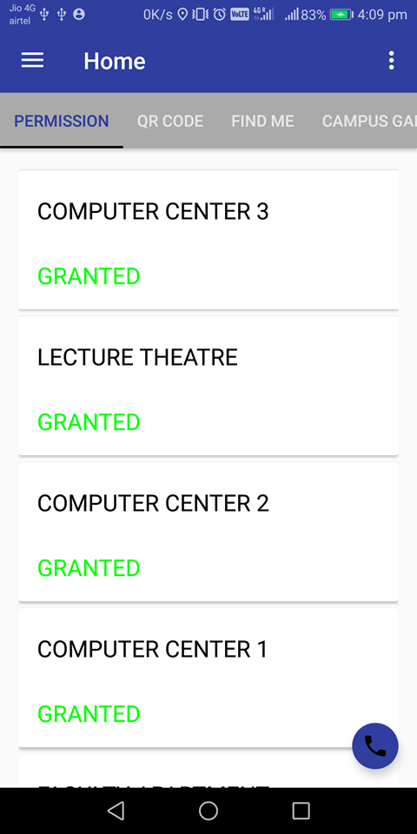

The various classes used and their Descriptions are as follow:

**MainActivity.java:**

This one is a Launcher class. It creates first screen of App , which simply load an animation of IIITA logo and automatically after finishing animation jump to Home.java.

ViewPropertyAnimator inner class was used for animation. Intents will be used for moving to next activity.

**Home.java**

This class is responsible for providing the service  of logging in if the user is signed out or want to register.If user is signed in automatically loads TabLayout and ViewPager.

In tablayout All tabs – Permission,QR Code,FindMe , Campus Gallery, Faculty Profiles are present. In ViewPAger , according to tabs corresponding fragment will appear.

Home also contains side menu by that we can see our profile, reviews and also we can give feedback.

Also a navigation Drawer which have user’s profile photo , name and mail at top, also contains menus as

Navigation Drawer -> UploadInfo.java (For Upload Information)

Navigation Drawer -> UpdateInfo.java (For update information)

Navigation Drawer -> PermissionFragment.java (visitor will get permissions)

Navigation Drawer -> Help (Instant help)

Navigation Drawer -> GalleryFragment.java (Campus Gallery)

Navigation Drawer -> AboutFragment.java (Faculty Profiles provided there)

Navigation Drawer -> Logout (for logout)

**PermissionFragment.java:**

If visitor is signed in and already have uploaded informations then according to his type and gender permissions will be allotted to the visitor by administration.

It contains RecyclerView -> CardView -> 2 TextViews (one for location , one whether it is granted or denied)

**QrFragment.java:**

This class is responsible for the generation of QR code. It uses the library **'com.journeyapps:zxing-android-embedded:3.2.0@aar', 'com.google.zxing:core:3.2.1'**

It’s implementation is as follow:

MultiFormatWriter mfw = **new** MultiFormatWriter();  
 BitMatrix bitMatrix1 = mfw.encode(str, BarcodeFormat.***QR_CODE***, 768, 768);  
 BarcodeEncoder bce = **new** BarcodeEncoder();  
 Bitmap bitmap = bce.createBitmap(bitMatrix1);  
 **sampleImage**.setImageBitmap(bitmap);  
  
 } **catch** (WriterException e) {  
 e.printStackTrace();  
 Toast.*makeText*(getActivity(), **"WriterException"**, Toast.***LENGTH_SHORT***).show();  
*// Toast.makeText(this, "dsfdfs", Toast.LENGTH_SHORT).show();* }

**FindFragment.java:**

In this we are providing user’s current location by its current latitude and longitude. It will also provide the find me Button in the application which can  be used to find the location of himself at any time.

**GalleryFragment.java:**

 We are providing some locations of campus with their brief introduction through this class. It will be responsible for showing the locations of Campus along with the brief introduction of those places.

**AboutFragment.java:**

This class is responsible for providing brief information of faculties like their name, official address, phone no., profile link of IIITA for the ease of visitors.

**MyAdapter.java:**

It is utility class for Home.java. All Tabs and content of viewPager will be represent by this class as an adapter. The code snippet is as follow :

**public class** MyAdapter **extends** FragmentStatePagerAdapter {  
 **private final** List<Fragment> **mFragmentList** = **new** ArrayList<>();  
 **private final** List<String> **mFragmentTitleList** = **new** ArrayList<>();  
  
 **public** MyAdapter(FragmentManager manager) {  
 **super**(manager);  
 }  
  
 @Override  
 **public** Fragment getItem(**int** position) {  
 **return mFragmentList**.get(position);  
 }  
  
 @Override  
 **public int** getCount() {  
 **return mFragmentList**.size();  
 }  
  
 **public void** addFragment(Fragment fragment, String title) {  
 **mFragmentList**.add(fragment);  
 **mFragmentTitleList**.add(title);  
 }  
  
 @Override  
 **public** CharSequence getPageTitle(**int** position) {  
 **return mFragmentTitleList**.get(position);  
 }  
  
 @Override  
 **public int** getItemPosition(Object object){  
 **return super**.getItemPosition(object);  
  
 }  
}

**PlaceAutoCompleteAdapter.java:**

It is used as utility class for MapActivity.java. This class is used for the purpose of giving suggestions of places while user is searching for a place In our map.

**ProfileActivity.java:**

It is a bottom Navigation Activity. In which there are three options:

1.       Home -> profile

2.       Feedback -> used to give Feedback

3.       Reviews -> used to see other visitor’s feedback about the campus.

**UploadInfo.java:**

This class is responsible for providing the facility of uploading the information which is to be stored on the firebase server.

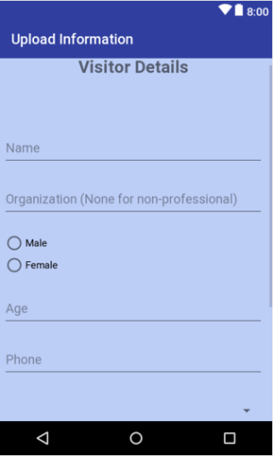

**Data libraries for Firebase :**

The various libraries which are used to store uploaded data in the firebase server are

implementation **'com.google.firebase:firebase-core:12.0.1'**

implementation **'com.google.firebase:firebase-database:12.0.1'**

implementation**'com.google.firebase:firebasestorage:12.0.1'**

**UpdateInfo.java**

The purpose of this class is to provide the facility of editing the existing user information. If at a particular instant if the user wants to change the info provided he can change from the update info button provided in sidebar.

**MapActivity.java**

This is one of the major class which hold all the map activities. Along with this GoogleApiClient for places and data is used for giving a much better experience to the users.

FusedLocationProviderClient  is used to get the visitor’s current latitude and longitude so that his position could be determined.

We used PlaceBuffer Inner class for autosuggestion or place prediction while visitor searching for a place inside this class.

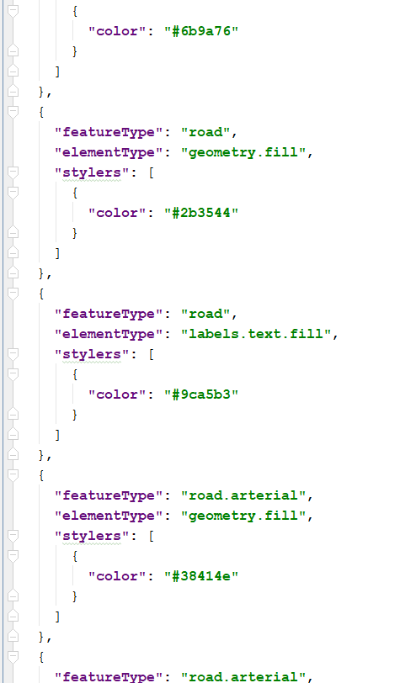

*Screenshot of the JSON file containing the map attributes*

Further tracking of visitor can be seen on dashboard where marker is being placed regularly whenever the visitor is changing its position with turn around time interval of 45 seconds averagely.

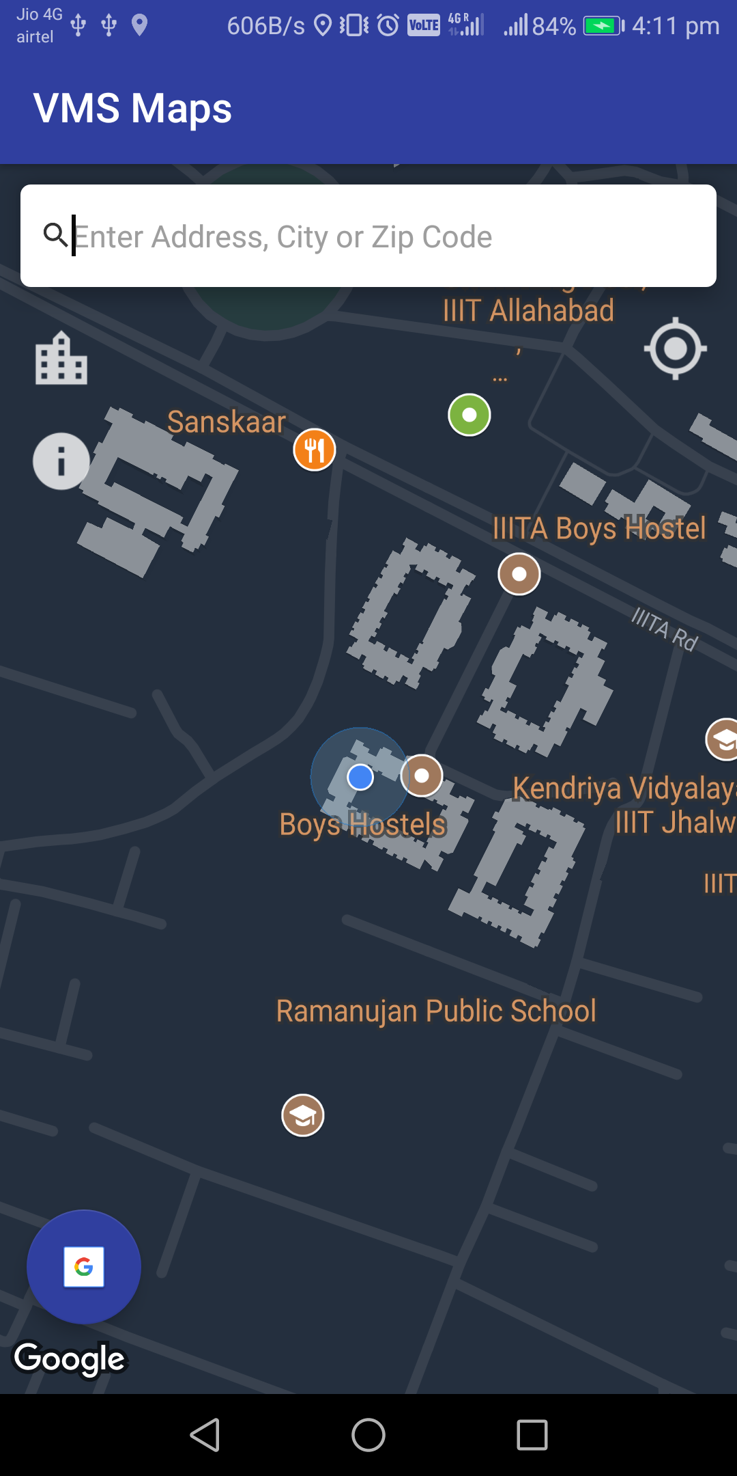**AndroidManifest.xml:**

This XML file lists all the permissions which the application needs on the smartphone. These permissions are needed to be granted for smooth use of application:

<**uses-permission android:name="android.permission.INTERNET"** />

<**uses-permission android:name="android.permission.ACCESS_FINE_LOCATION"** />

<**uses-permission android:name="android.permission.ACCESS_COARSE_LOCATION"** />

<**uses-permission android:name="android.permission.ACCESS_NETWORK_STATE"** />

<**uses-permission android:name="android.permission.CALL_PHONE"** />

<**uses-permission android:name="android.permission.READ_PHONE_STATE"** />

<**uses-permission android:name="android.permission.ACCESS_NETWORK_STATE"** />

**HelpActivity.java**

This class will provide the facility of dialing or making the phone call for any kind of help. There are some of the default numbers stored in any case if a visitor needs assistance he can call on any of the provided number. The implicit intent for calling

Intent callIntent = **new** Intent(Intent.***ACTION_CALL***);  
*// Set the data for the intent as the phone number.*callIntent.setData(Uri.*parse*(phoneNumber));  
*// If package resolves to an app, send intent.***if** (callIntent.resolveActivity(getPackageManager()) != **null**) {  
 **if** (ActivityCompat.*checkSelfPermission*(**this**, Manifest.permission.***CALL_PHONE***)  
 != PackageManager.***PERMISSION_GRANTED***) {  
 **return**;  
 }  
 startActivity(callIntent);  
} **else** {  
 Log.*e*(***TAG***, **"Can't resolve app for ACTION_CALL Intent."**);  
}

**Development of Admin Dashboard:**

For the Development of Admin Dashboard HTML, CSS, JavaScript And JQuery languages are used.

The IDE used for development wasATOM.

**Hardware on which implemented:**

Intel Core i5 Processor 6th gen

RAM: 8GB

Hard Disk: 1TB

**Softwares and OS:**

OS - Windows 10

Working Internet Browser - Google Chrome(Recommended)

**Development phases :**

**Developing authentication page:**

The first step in development of Admin Dashboard is creating an Authentication page so that authenticated users are only allowed to login.

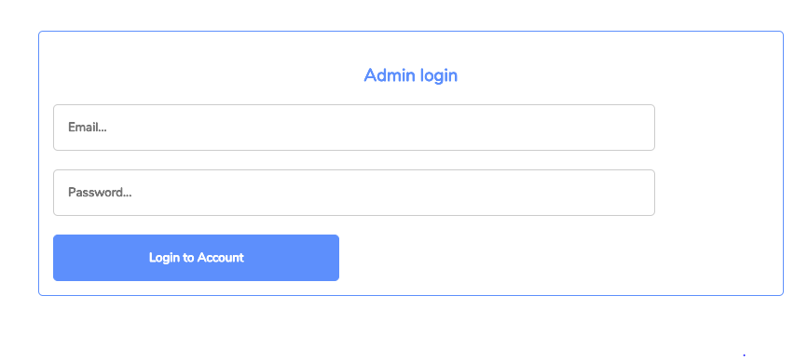

The page is simply Designed with the help of HTML

Connected with the local server For Authentication of valid user. Which later on is planned to move on online server.

**Form For New Visitor:**

Once the visitor Comes into the campus he has to give his details at the main gate. For storing the information of the visitor and providing the link on the given email id is done by the Guard sitting on main Gate.

The from is simple asking for Visitor Name ,Contact no. and Email Id.

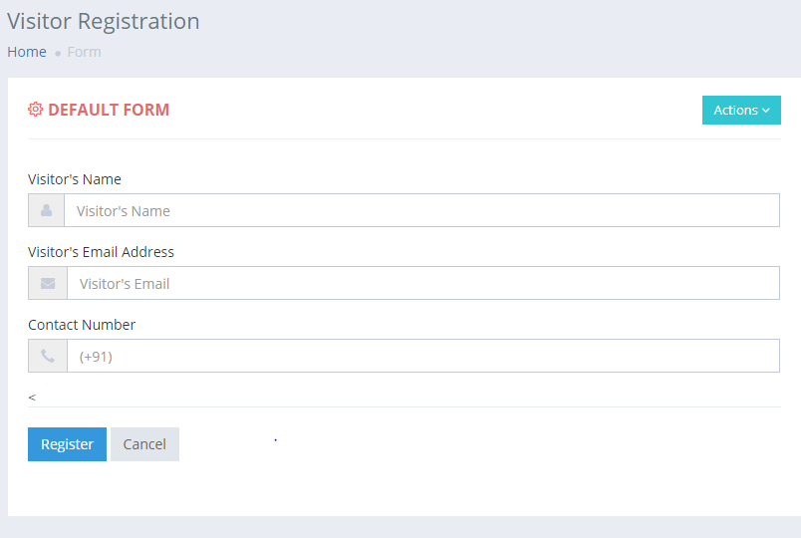

**Sending Application link:**

Once the visitor provide the information required at the main gate the guard fills the above form and click on the Register button. As the Register button is pressed the Email containing the android application link is sent on the Email ID provided by the visitor.

For automatic Email Sending we have used the External Site which provides the facility of sending messages through the written JavaScript code.

The API used for Email Sending is provided by EmailJS.

Initially The following Script is added in the header of Visitor Form page

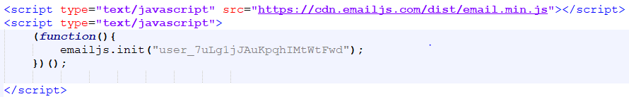

And the second script is added in the Action of Register button which sends the Automatic Email to the Mail Address provided by the visitor.

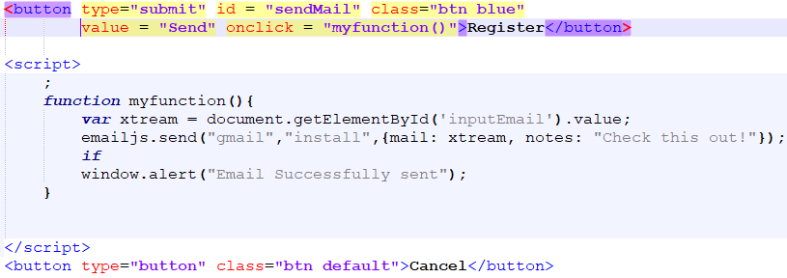

**Connecting to the Firebase:**

The JavaScript program is written for connecting to the firebase server. Which is then used inside the HTML page in order to display the retrieved information from the server

The following JavaScript Code is used For Connecting to firebase Server :

var config = {

apiKey: <YOUR_API_KEY>,

authDomain: "visitormanagement-***ac.firebaseapp.com",

databaseURL: "https://visitormanagement-***ac.firebaseio.com",

projectId: "visitormanagement-****c",

storageBucket: "visitormanagement-*****.appspot.com",

messagingSenderId: "109*******598"

};

firebase.initializeApp(config);

With the help of this script firebase server can be connected to.

**Retrieving Data from the Firebase Server:**

Once you are connected to the firebase server the next step is retrieving the information stored on the firebase server according to the users requirement.

The structure of Data stored on Firebase server is as follow:

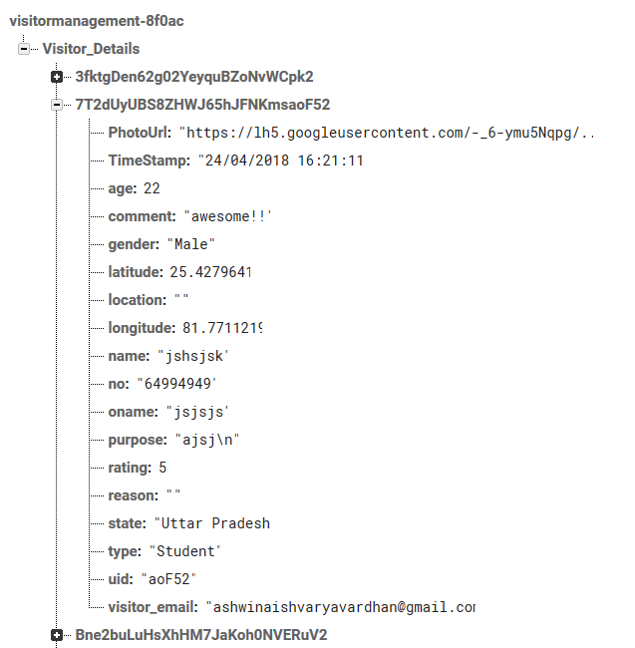

To retrieve the each info from the Firebase the following script code is used.

var rootRef = firebase.database().ref().child("Visitor_Details");

rootRef.on("child_added", snap => {

var name=snap.child("name").val();

var phone_number=snap.child("no").val();

var organisation_name=snap.child("oname").val();

var purpose=snap.child("purpose").val();

var uid=snap.child("uid").val();

var visitor_email=snap.child("visitor_email").val();

var gender=snap.child("gender").val();

var type=snap.child("type").val();

var rating=snap.child("rating").val();

var comment=snap.child("comment").val();

console.log(snap.val());

$("#table_body").append("<tr><td>" + name + "</td><td>" + phone_number +

"</td><td>" + organisation_name + "</td><td>" + purpose + "</td><td>" + uid +

"</td><td>" + visitor_email + "</td><td>" + gender + "</td><td>" + type + "</td><td>" + rating + "</td><td>" + comment + "</td></tr>");

});

The Retrieved data is then stored inside the Responsive Table

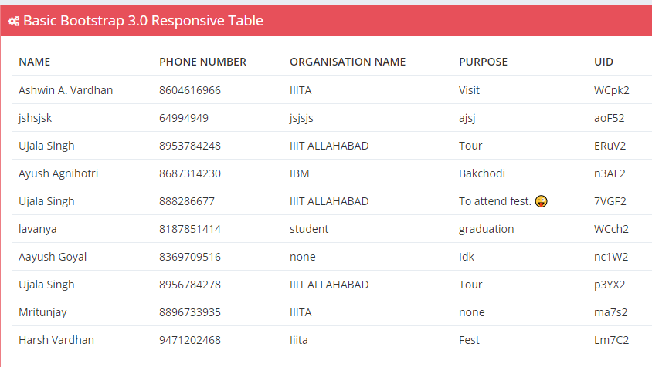

**Data Visualization:**

The final task of Admin Dashboard is Visualization of data. Based on the Retrieved data from the firebase server. The data is shown with different Attributes. The Data is shown By type of Visitors, Visitors Address, Visitors Count Etc.

The information Retrieved is initially stored in the local Tables after that Data is Visualized from those local table.

Everything is done inside the index.html which is the Home Screen For the Dashboard. The Data is visualized using the JavaScript Codes.

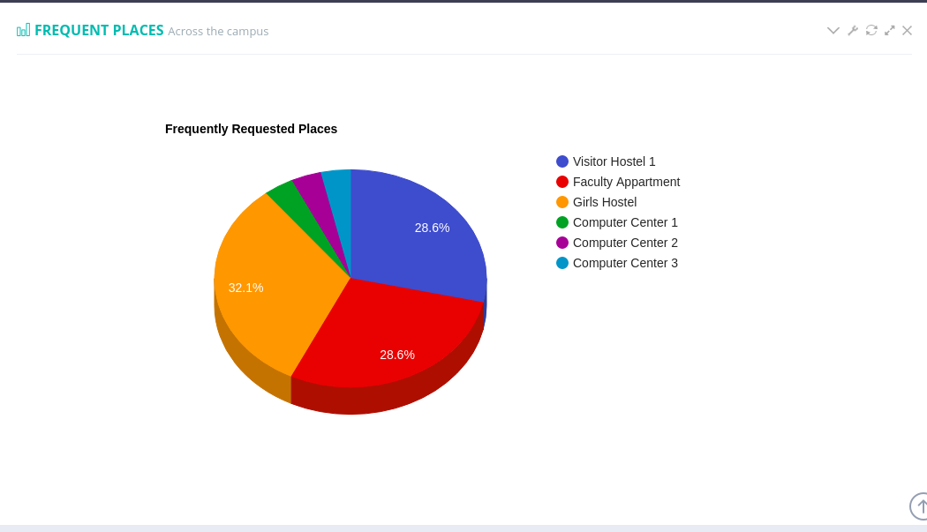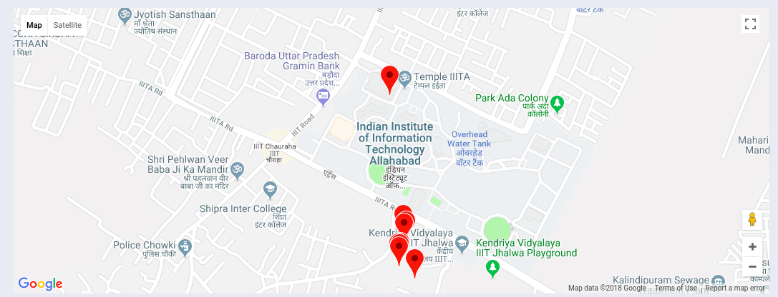

Showing Frequently Requested places

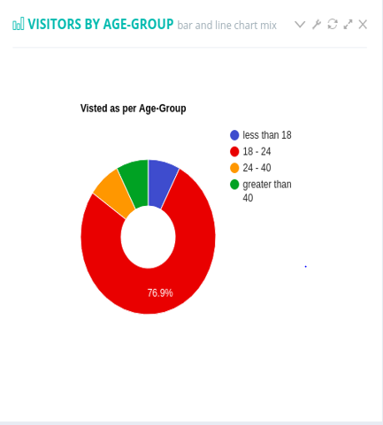

Visitor According to age groups

**Real Time Tracking Of Visitors:**

Once an individual installed his/her app , our app will detect the change in the individuals position through GPS and as soon as the users move his latitude and longitude value will start showing the deflection in database . These changes will be recorded in our back end and the marker of the corresponding individual will start moving from its position allowing us to track the individual . Even if the server is down it will still show us the last place where he/she was.

**RESULTS**

The application for the visitor tracking is developed. Which is tested and is showing the significant results such as precise location of the visitor. The application is also capable of maintaining the accesses to the visitors and maintaining the digital records.

The application is ready for visitors fulfilling all the basic requirements. And the Admin Dashboard is also ready for monitoring the visitors.

**FUTURE SCOPE**

With this project, we are expecting a flurry of similar projects being initiated in future. Some of them include:

* Integration with PayTM, Tez, BHIM and other wallets can be provided, for hassle-free payments.
* Chat services can be added besides existing calling feature.
* Security of female students can be enhanced, both within as well as outside the campus.
* Students can focus more while giving exams if QR mapping is implemented.
* A feature to fix appointments with faculty, doctors can be added.
* Providing QRs to all students for attendance.
* Provision of QR Code to all male students so as to reduce time and effort required at the pocket gate and main gate in checking the ID cards.
* Provision of QR Code to all female students for timely security alerts in case she doesn’t return to the campus within a stipulated time.
* Visitor Count Prediction can also be done using Machine Learning based on the previous data obtained.
* The search bar in our Map requires deep learning to function effectively, hence, that can be done.

**CONCLUSION**

We can conclude that the objectives that we had decided before starting this project, have been met with success, and while the software still needs refinement and maintenance (as it will always do), we believe that we have been successful as far as development of prototype goes.

Yet, there are still some of the tasks and developments needed to be done in Admin Dashboard for Controlling access and visualization of data of all the visitors.

Digital logs of the visitors is yet to be generated.

**References**

[1] Al-barhamtoshy, H, Altalhi, A & Mashat, A. (2014). Automation of Attendances in Classrooms using RFID. *International Journal of Scientific & Engineering Research*, 5(2), 2229-5518.

[2] Sharma, S, Chatterji, S & Shimi, S. (2014). Radio Frequency Identification (RFID) Based Employee Management System (EMS). *International Journal of Engineering Science Invention*, 3(10), 2319 – 6734.

[3] Karthika, P, Harriet rathna priya, J & rathinavel pandian, A. (2015). Indoor Location Tracking System Using RFID Technology. *International Journal of Engineering Research and Reviews*, 3(1), 73-80.

[4] W. Coon, Location-Aware RFID Mobile Device System for Museum Applications, *University of Colorado, Boulder, pp. 1-3, 2011*

[5] Ankit Bhandari, Kirti Wattamwar, Pragya Preeti, Susheel Bhatt & B.B. Gite "Automated Visitors Management System," *Computer Engineering, Sinhgad Academy Of Engineering ,* pp. 46-48, 2012

[6] A fisher, J & Monahan, T. (2008). Tracking the social dimensions of RFID systems in hospitals. *International journal of medical informatics*, 77(1), 176-183.

[7] Neelesh Gupta,  Devyani Bajaj, "GPS Based Automatic Vehicle Tracking Using," *International Journal of Engineering and Innovative Technology (IJEIT) ,* vol. 1, no. 1, pp. 31-35, 2012.

[8]. Nikhil Gudla, A Wahid Khan, Sai Kalyan Paladagu , Raja Venkata Satya Phanindra Chava  "The Student Tracking Using RFID Technology," *International Journal of Applied Engineering Research ISSN 0973-4562,* vol. 11, no. 1, pp. 173-176, 2016.

[9] Umar Farooq, Mahmood ul Hasan, Muhammad Amar, Athar Hanif, Muhammad Usman Asad "RFID Based Security and Access Control System," IACSIT International Journal of Engineering and Technology, pp. 309-314, 2014.

[10] Abhishlin Blessy,  Jebah Jaykumar, "Secure Smart Environment Using IOT based on RFID," *International Journal of Computer Science and Information Technologies,* vol. 5, no. 2, pp. 2493-2496, 2015

[11] Lei Chen,Wei-guo Song,Fei-zhou Huo, "Study of Personnel Monitoring and Counting in Single Channel Based on RFID Technology " *ScienceDirect ,Procedia Engineering ,* 71, pp. 529-536, 2014.

[12] Sungjun Kim, Doohyun Ko, Sunshin An, “Geographical Location Based Tracking System, ”*Institute of Electrical and Electronics Engineers* , 978-1-4244, 2008

[13]  Sumit Tiwari, “An introduction to QR Technology,” International Conference on Information Technology, pp.39-44,2016.